1. Query the average population of all cities in **CITY** where District is **California**.

1. Query the average population for all cities in **CITY**, rounded down to the nearest integer.

Solution-select round(avg(population)) from city;

3) Sol - select a.hacker_id,a.name,count(b.hacker_id)

from Hackers a, Challenges b

WHERE a.hacker_id = b.hacker_id

GROUP BY a.hacker_id,a.name

HAVING count(b.hacker_id) not in (select distinct count(hacker_id) from Challenges

WHERE hacker_id != a.hacker_id

group by hacker_id

having count(hacker_id) < (select max(x.challenge_count)

from (select count(b.challenge_id) as challenge_count from Challenges b GROUP BY b.hacker_id) as x ))

4) Query the sum of the populations for all Japanese cities in **CITY**. The COUNTRYCODE for Japan is **JPN**.

Solution-select sum(population) from city where countrycode='JPN';

5) Query the difference between the maximum and minimum populations in **CITY**.

Solution-select max(population)-min(population) from city;

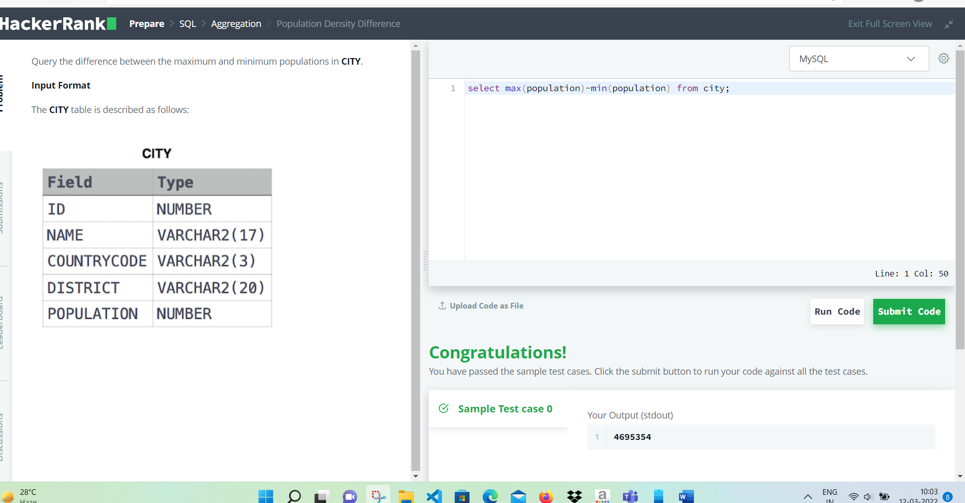

6) Write a query calculating the amount of error (i.e.:  average monthly salaries), and round it up to the next integer.

